T Account Practice
NAME____________

The following transactions relate to Smith Consulting Services for the month of November 2025. The owner of the company is Joe Smith. Use the following accounts:
Assets: Cash Liabilities: Accounts Payable
Accounts Receivable Owner’s Equity: Smith, Capital
Office Supplies Smith, Withdrawals
Equipment Revenue: Service Revenue
Expenses: Rent Expense
Salaries Expense
Utilities Expense
Transactions:
- The owner withdrew $50,000 from his personal savings account and deposited it into the new business checking account for Smith Consulting Services.
- The business paid $5,000 to purchase a computer and other equipment.
- The business paid $2,000 rent for the current month.
- The business paid $500 to Resource Supplies to purchase office supplies.
- The business purchased office equipment for $12,000 on account from Office Plus.
- During the month the business earned $11,000 in revenue from clients who paid cash.
- During the month the business earned $4,000 in revenue from clients on account.
- The business paid $2,500 to Office Plus to pay towards the debt of $12,000.
- Charge account clients paid $3,000, reducing the amount owed to the business.
- The business paid $6,000 in salaries to employees.
- The business paid $800 for utilities.
- The owner withdrew $3,500 cash for personal use.

Required:
Show the transactions in T Accounts. Complete a Trial Balance.

Debit/Credit rules:
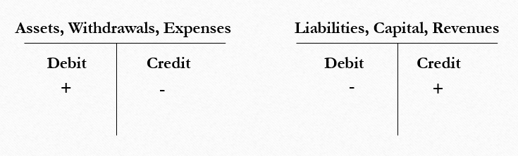

T Accounts

Cash Accounts Receivable Office Supplies

Office Equipment Accounts Payable

Smith, Capital Smith, Withdrawals

Service Revenue

Rent Expense Salaries Expense Utilities Expense

Smith Consulting
Trial Balance
November 30, 2025
Account | Debit | Credit
Cash
Accounts Receivable
Office Supplies
Office Equipment
Accounts Payable
Smith, Capital
Smith, Withdrawals
Service Revenue
Rent Expense
Salaries Expense
Telephone Expense
TOTAL

